
NEWSLETTERS – DECEMBER 2025

Transition in Ownership & Introduction of Aldesta
We are pleased to announce that Fairmont Mountainside Villas has transitioned to new management under Aldesta Hotels, marking an important new chapter for the property.
We’re excited to share that Fairmont Mountainside Villas is now part of the Aldesta Hotels family. This is a special property with a strong history and a community of owners who truly care about it. We’re looking forward to building on that foundation and continuing the success that’s already here. Our team is settling in, learning the property, and we’re eager to work with all of you as we move forward together.
Tony Medd
Vice President of Hotels
Aldesta Hotels


As part of this transition, we are pleased to introduce our new management team:
- General Manager: Jesse Ferguson, overseeing the Fairmont Hot Springs resort as well as the MountainSide Villas. (jferguson@fhsr.com)
- Front Office Manager: Nina Stashenko. Nina has been working at the villas for already 2,5 years, in housekeeping, front desk and reservations. (frontdeskmgr@msvillas.com)
- Housekeeping Manager: Martha Lua Sanchez (hskpmgr@msvillas.com)
- Maintenance Supervisor: Robert Semeredi
We look forward to continuing to provide excellent service under this refreshed leadership.

Staff Appreciation
We want to express our sincere gratitude to the dedicated staff members who supported MountainSide Villas for many years and who remained with us through the ownership transition. Their commitment has been invaluable, and although many have now chosen to enjoy a well-deserved retirement, they continue to offer guidance when needed. We are grateful for their legacy and wish them all the best.
A big thanks to Jean, Lorna, Dale, Julie, Rory, Michelle, Heinz and Kathy.

A Special Thank-You to Our Support Teams
We would also like to extend our heartfelt appreciation to the many individuals from across the Fairmont Hot Springs Resort, our Head Office, and the various Aldesta hotels who assisted during the ownership transition and the implementation of our new reservation system. Your willingness to step in, share expertise, and support our team—often on very short notice—has been invaluable. Your contributions have made a meaningful difference, and we are truly grateful for your dedication, patience, and teamwork throughout this process.
Updated Operating Hours
Please note the following changes:
- Reservations Department:
Monday, Thursday, and Friday — 9:00 a.m. to 5:00 p.m. MST
You can call 1-855-345-6341
or email resweb@msvillas.com or resone@msvillas.com
Booking day is on Friday
If you call outside of these hours, the Front Desk staff can transfer your call to the reservation desk voicemail, but they will not be able to make your booking.
- Recreation Center:
Open daily from 11:00 a.m. to 7:00 p.m.
Check-ins after 7:00 p.m. will be handled at the Fairmont Hot Springs Resort front desk.
- Pool & Hot Tubs:
Open from 9:00 a.m. to 10:00 p.m. Accessible from outside while the recreation center is closed. (Previously closed at 8:45 p.m.)

Check-in & Check-out Times
- Check-in time is any time after 4:00pm on your arrival date
- Check-out time is any time prior to 10:00am of your departure date
- Early check-ins or late check-outs are not permitted.
Villas can only be released after they have been checked and approved by the Housekeeping Manager. We ask that you refrain from going over to the villa until it has been released for occupancy. If the unit is ready prior 4pm, we will be happy to let you in early.

Booking & Calendar Updates
- 2027 Booking Calendar: Find below the booking calendar for reservations done in 2026 for a stay in 2027. (Insert link for download)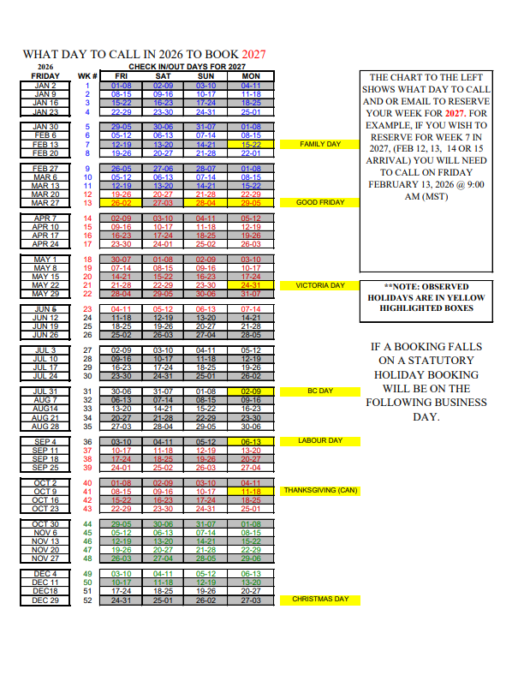
FLOATING OWNERSHIP bookings are made on a first come, first serve basis according to space availability. Bookings can be made up to one year in advance on a week number basis, beginning the first weekday of the week in the year preceding the sought-after week of arrival based on the Mountainside Vacation Schedule. Thus, the first day anyone may arrange for a reservation in the coming year will always be a Friday (or Monday, if the Friday is a statutory holiday).
FIXED OWNERSHIP bookings are automatically done, but owners need to call at least 2 weeks prior to check-in to confirm the arrival/departure dates due to calendar changes.

The table below shows the Villas that are not available for booking at anytime during the year, except for nightly rentals.

Villas not available in 2026 and 2027
R4, 5, 6 & 7
S1 & 3
T1, 2, 5 & 6
W1, W2
X1, 2, 3, 4, 5 & 6

Depositing Weeks
If you would like to deposit your time with an external exchange company, you will need to reserve your week at your home resort (Mountainside Villas) up to one year in advance in order to trade a week here for a week elsewhere.
You must deposit the weeks up to 120days in advance to receive full points with CIG and at least 30 DAYS (previously 2 months) in advance for regular week deposits to ensure a regular deposit, or 14DAYS before c/i for Late (Flex) deposits.
Maintenance fees must be paid for week(s) depositing

Multi-week Stays
If you are staying for multiple weeks and would like a second clean, please let the Front Desk staff know at check-in what time you would like the clean.
The second clean will take place on the day that you checked in i.e. if you check-in on Friday the clean will be the following Friday. The Housekeeping team will do their best to schedule the clean for the time requested.

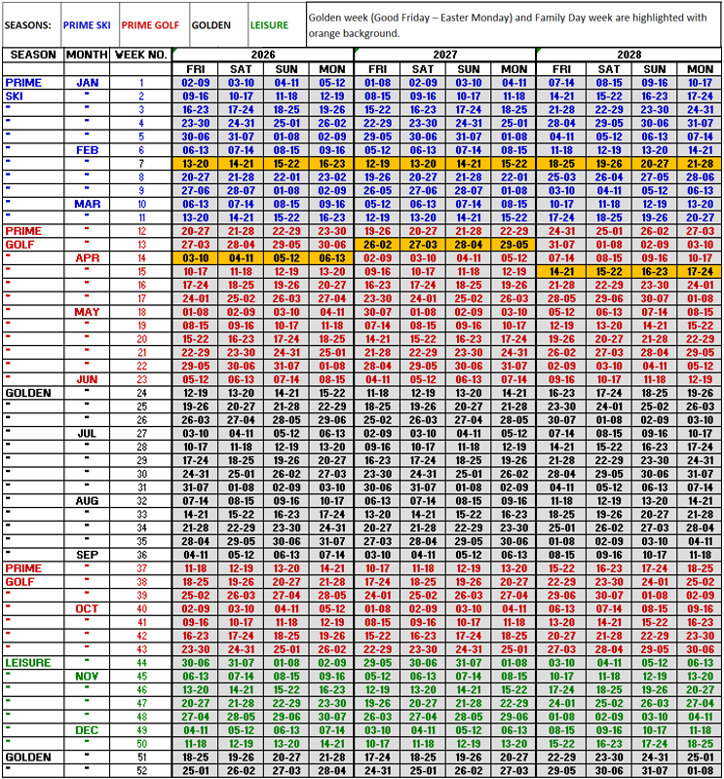
- 2026–2028 Check-in Day Calendar: Also available for your reference, the check-in day date per week. 2026-2030 Check-in day calendar available to download (Insert link for download)
2026 Maintenance Fees
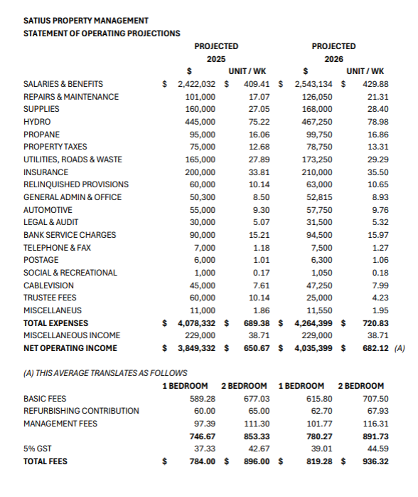
1 bedroom: 819.28 CAD
2 bedrooms: 936.32 CAD
You may now contact us to begin payment arrangements. Payments are due by January 31, 2026

NOTICE FOR COMMUNICATING TO OWNERS
- Communication to our owners will continue to be posted on our website;
- Rental and reservation confirmations will be emailed;
- Invoices in January will be emailed
- Quarterly statements will be emailed.

FOR THESE REASONS, IT IS EXTREMELY IMPORTANT TO KEEP US INFORMED OF ANY CHANGES TO YOUR EMAIL AND MAILING ADDRESS.
YOU CAN PHONE THE OFFICE ON 1-855-345-6341
OR
EMAIL FRONTDESK@MSVILLAS.COM

PET POLICY
We are issuing a friendly reminder to all owners and guests, that Mountainside Vacation Villas has always been a NO PETS property. There are kennels in our area and you may contact them in advance to set up that service. Information can be found on our website under the “services” tab.
As per the BC Government Guide Dog and Service Dog Certification program, only Guide and Service Dogs that are specially trained by an accredited training school, and government certified, are permitted. British Columbia’s Guide and Service Dog Certification program states:
“Therapy and emotional support animals, including dogs, are not eligible for certification.”
A link to our complete PET POLICY can be found on our website.
If a Guide or Service Dog will be arriving with you, documentation is required 3 WEEKS PRIOR to your arrival by email to Nina at frontdeskmgr@msvillas.com

What’s New at MountainSide Villas
We have several updates to enhance your experience:
- New Reservation System:
We recently implemented a new system. While the transition has been challenging, we are confident it will improve efficiency for both owners and staff moving forward.
- Phone System Upgrade:
A full upgrade to our office phone system is planned for 2026.
- Hot Water Restored:
Hot water service has been fully restored in the recreation center changing rooms.
- Linen Improvements:
A significant order of new linens has arrived, helping us address ongoing laundry and supply challenges.
- Pool table:
The pool table at the recreation center is now FREE to use, come enjoy a game!
- Movie rental
Movies are now available to borrow free of charge.
- Natural Hot Springs pools discount
From January 2026 the Villas guests and owners will be able to access the Natural Hot Springs pools located at the Fairmont Hot Springs resort at a discounted price.
- Activities
The Villas guests and owners have access to all activities included at the Fairmont Hot Springs Resort. The schedule is different every month and is available at the recreation center lobby and online (click here and then on “View December Activities”)

Current Challenges
Like many businesses in the valley, we continue to face significant staffing challenges. Recent changes to immigration regulations have made hiring even more difficult, and we have unfortunately lost several exceptional team members.
Despite these obstacles, our current team is working diligently to find solutions. Our priority is to restore the recreation center and reservations department to full operating hours as soon as staffing permits.

We appreciate your patience and support during this period of transition. If you have any questions, please feel free to contact us.
Warm regards,
The MountainSide Villas Management Team



As the year comes to a close, we would like to extend our heartfelt wishes for a joyful holiday season to you and your loved ones.
Your continued trust and support mean so much to our entire team, and we are truly grateful to have you as part of the MountainSide Villas family.
We hope the holidays bring you rest, happiness, and time spent with those who matter most.

We look forward to welcoming you back in 2026 and in the many years ahead. From all of us at MountainSide Villas, we wish you a healthy, peaceful, and prosperous New Year.



